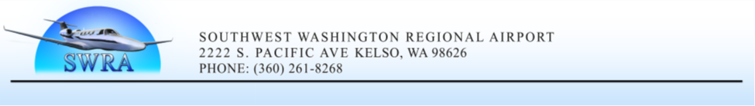**Special Airport Operating Board Meeting Agenda**

**June 24, 2025 @ 12:00 pm**

**Meeting Location:** Airport FBO (Cascade Air): 2215 A Parrott Way, Kelso, WA 98626

1. **Opening Items:** 
   1. Chairman (Cowlitz County): Call to Order
   2. Roll Call
   3. Pledge of Allegiance
2. **Minutes:**

2.1 N/A

1. **Treasurer Report and General Claims:** 
   1. N/A
   2. N/A
2. **Citizens Business:** Public Comment Period
3. **Action Items:** 5.1 Review/Approve Draft 2026 Airport Operating Budget (**Action**)
4. **Other Items:**

N/A

1. **Executive Session:** N/A
2. **Adjourn Board Meeting**

Board chairman: Wrap up and announce next board meeting date (**July 17, 2025**)